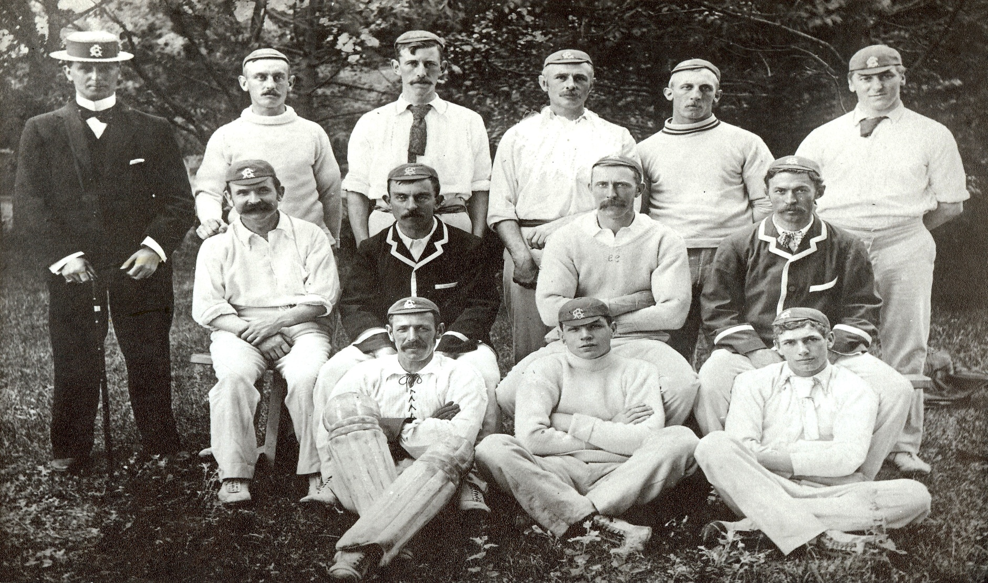

**Canterbury Representative team 1897/98**

**Back row:** FC Raphael, HC Ridley, CW Garrard, F Wilding, WC Pearce, WCH Wigley

**Middle row:** J Wheatley, AE Ridley, CR Clark (captain), LT Cobcroft

**Front row:** JN Fowke, D Reese, A Sims